Laporan UTS Rekayasa Perangkat Lunak

|  |  |
| --- | --- |
| Nama Mahasiswa | Harry Juliansy Fikri Semendawai |
| NIM | 1800016143 |
| Kelas Perkuliahan ADSI | A |

# Use Case

|  |  |
| --- | --- |
| Use Case Name | Analisa perancangan sistem informasi minimarket |
| Actors | Pegawai, pelanggan, barang, supplier transaksi |
| Description | membahas tentang perancangan data dan perancangan proses dengan studi kasus Sistem Informasi Swalayan |

# Class Diagram

Kasir

Supplier

Pelanggan

Pengurus Gudang

Pemilik

# Database Model

|  |  |
| --- | --- |
| Database Engine | Postgresql |
| Version | pgAdmin 4 |

Table Name:

|  |  |
| --- | --- |
| Nama | Field |
| Tabel Karyawan | * Id_karyawan * Nama * Umur * Jenis_kelamin * Alamat * No Hp * Foto |
| Tabel Pelanggan | * Id_member * Nama * Jenis_kelamin * Alamat * No Hp * Email * Point |
| Tabel Supplier | * Id_supplier * Nama Toko * Alamat * No Telp * Email |
| Tabel Barang | * Id_barang * Nama * Merk * Harga * Jumlah * Kualitas * Foto |
| Tabel Order Penjualan | * No_nota * Id_Kasir * Id_pelanggan * Id_barang * Tanggal_transaksi * Jumlah_barang * Total |
| Tabel Order Penjualan | * No_Faktur * Id_supplier * Id_barang * Id_pegawai * Tgl_pesan * Jumlah_barang * Total |

# Implementasi Class Diagram pada Sisi Server

|  |  |
| --- | --- |
| Application Name | Sistem Informasi Supplier MiniMarket |
| Programming Language | Java |

## Struktur File

* java
* com.example.authentication
  + controller
* AuthRestAPIs
* DemoController
* TestRestAPIs
* request
* LoginForm
* SignUpForm
* response
* Response
* model
* Role
* RoleName
* User
* service
* UserService
* UserPrinciple
* AuthenticationApplication

## Kode Program

* AuthRestAPIs

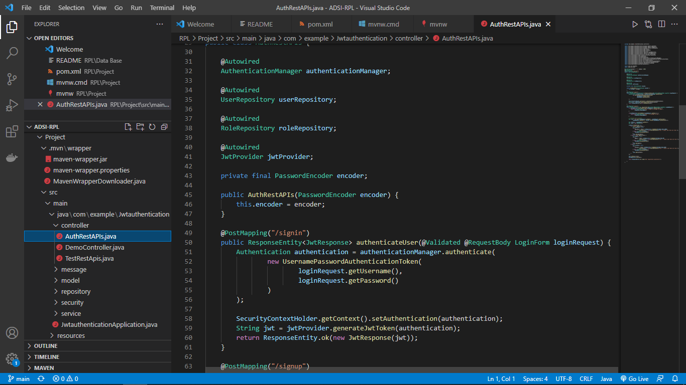

* DemoController

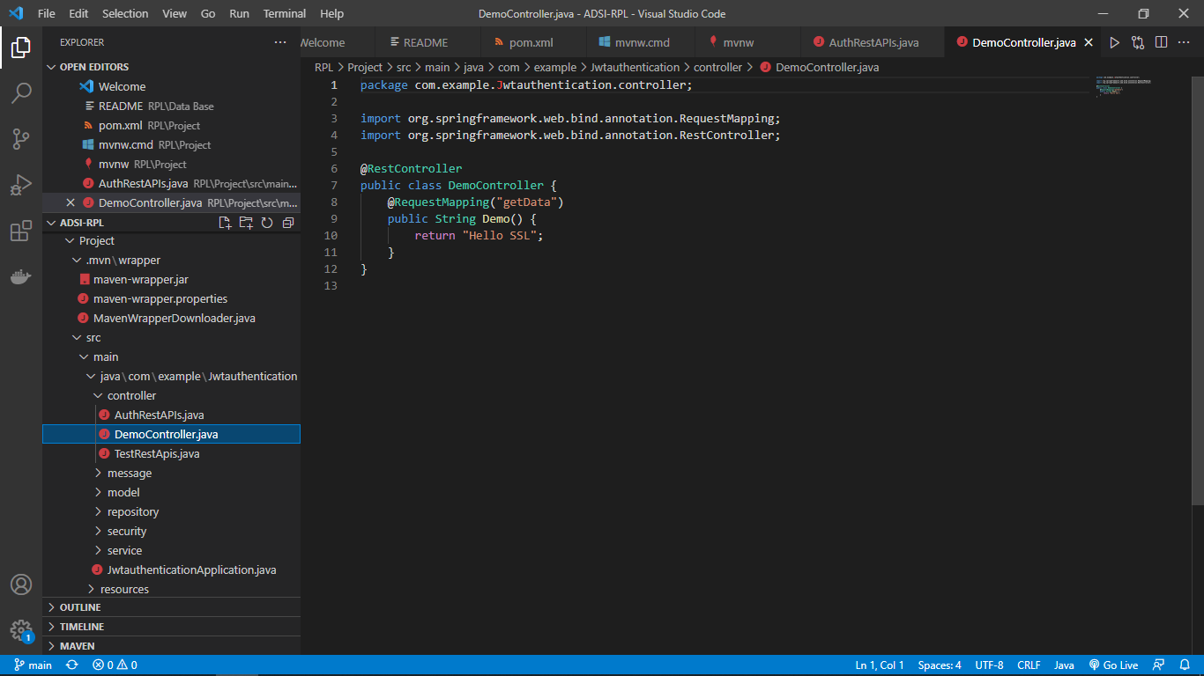

* TestRestAPIs

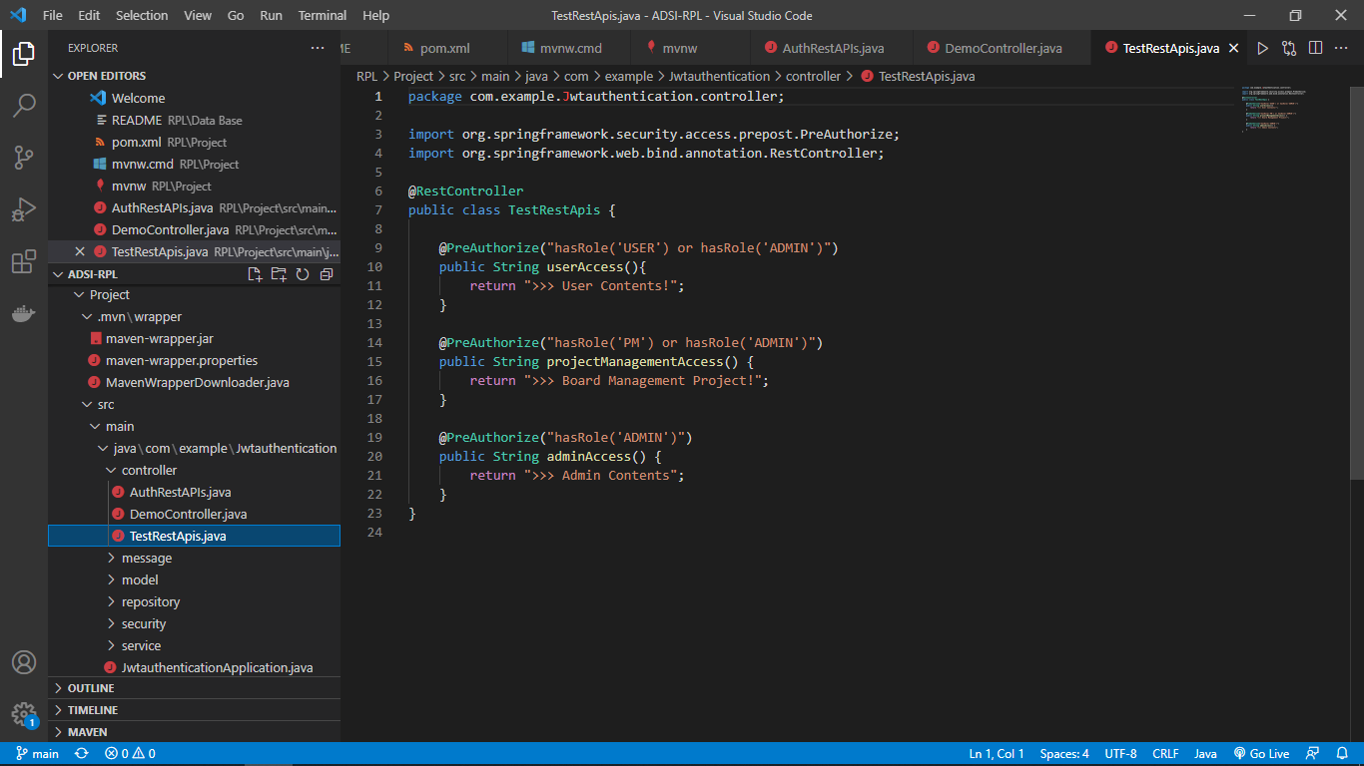

* LoginForm

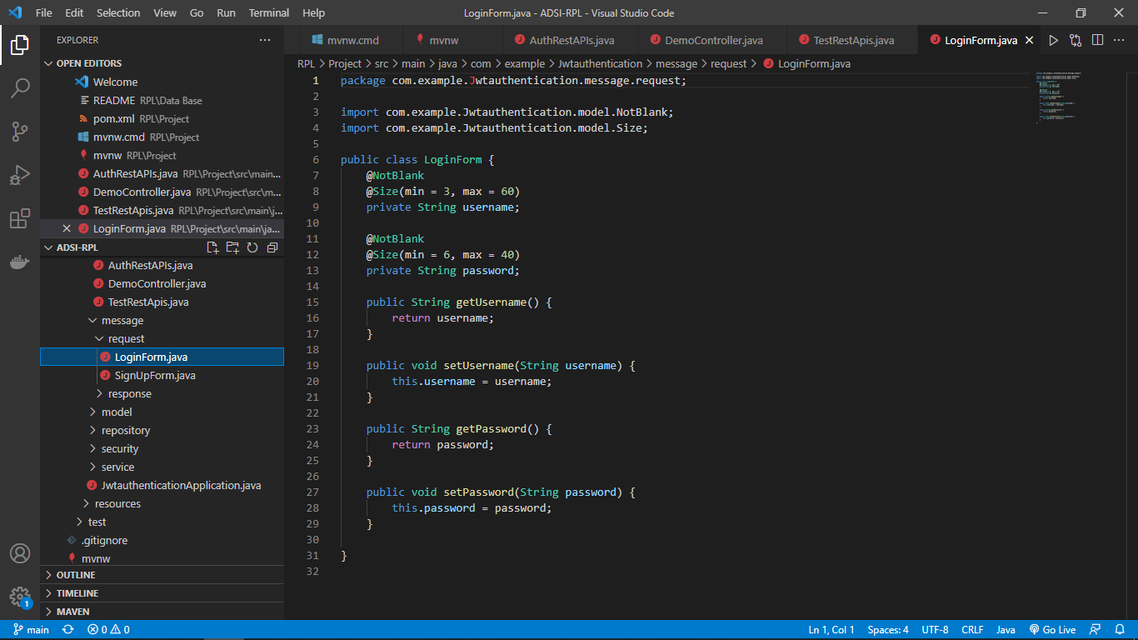

* SignUpForm

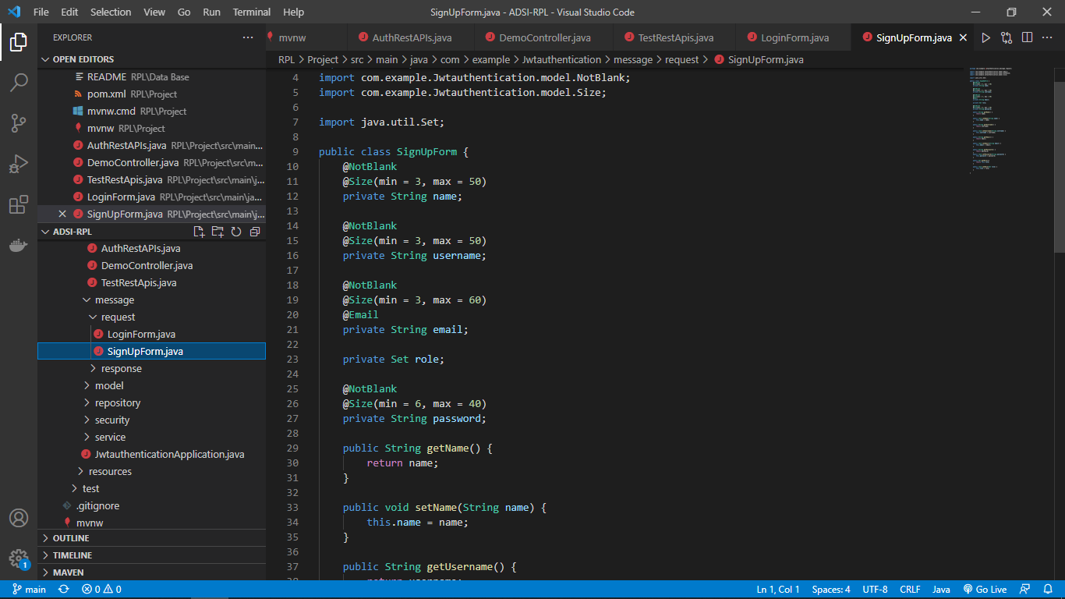

* Response

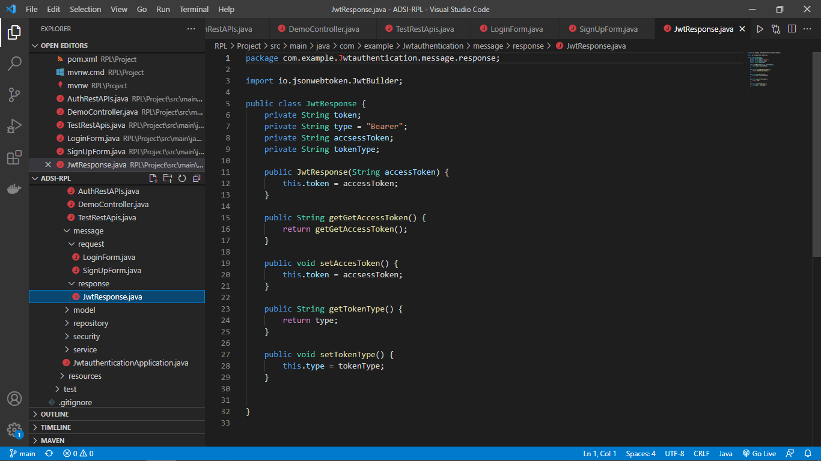

* Role

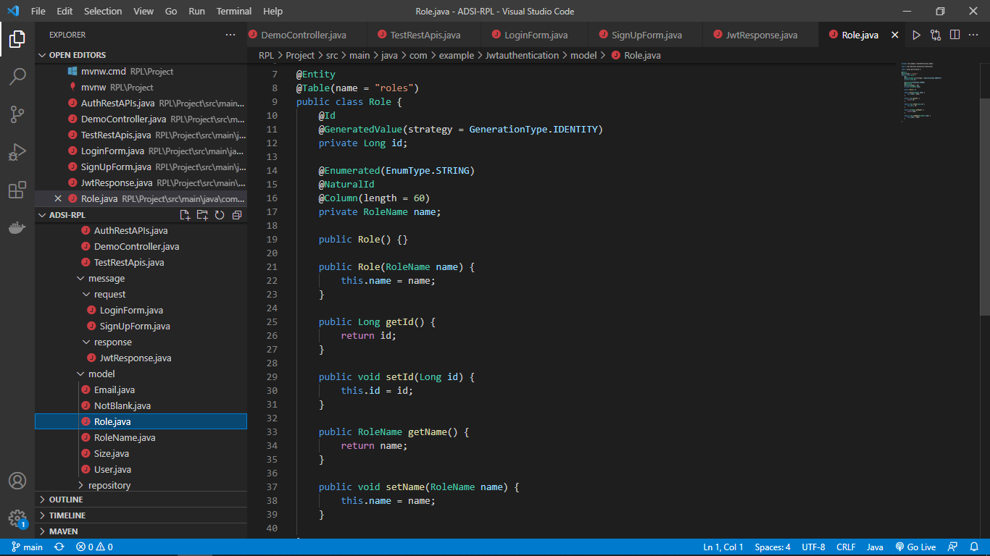

* RoleName

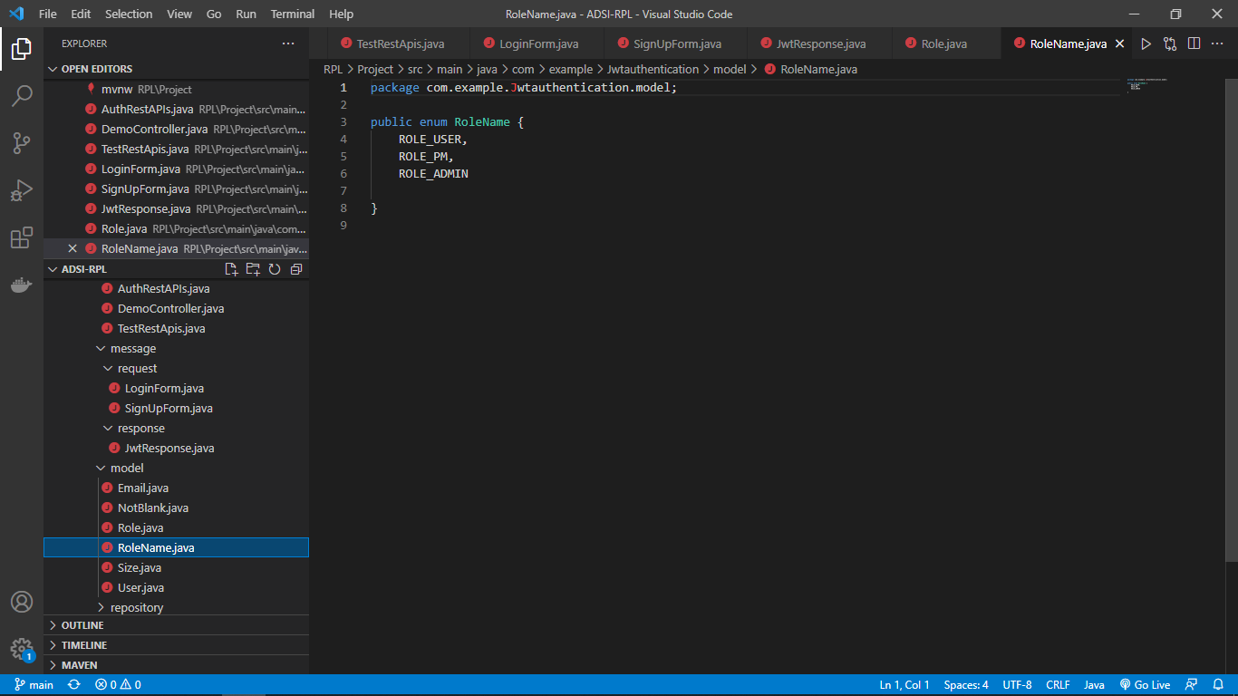

* User

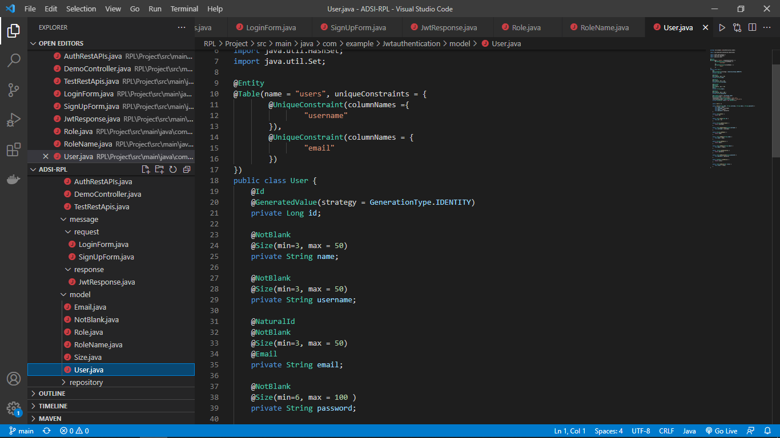

* UserService

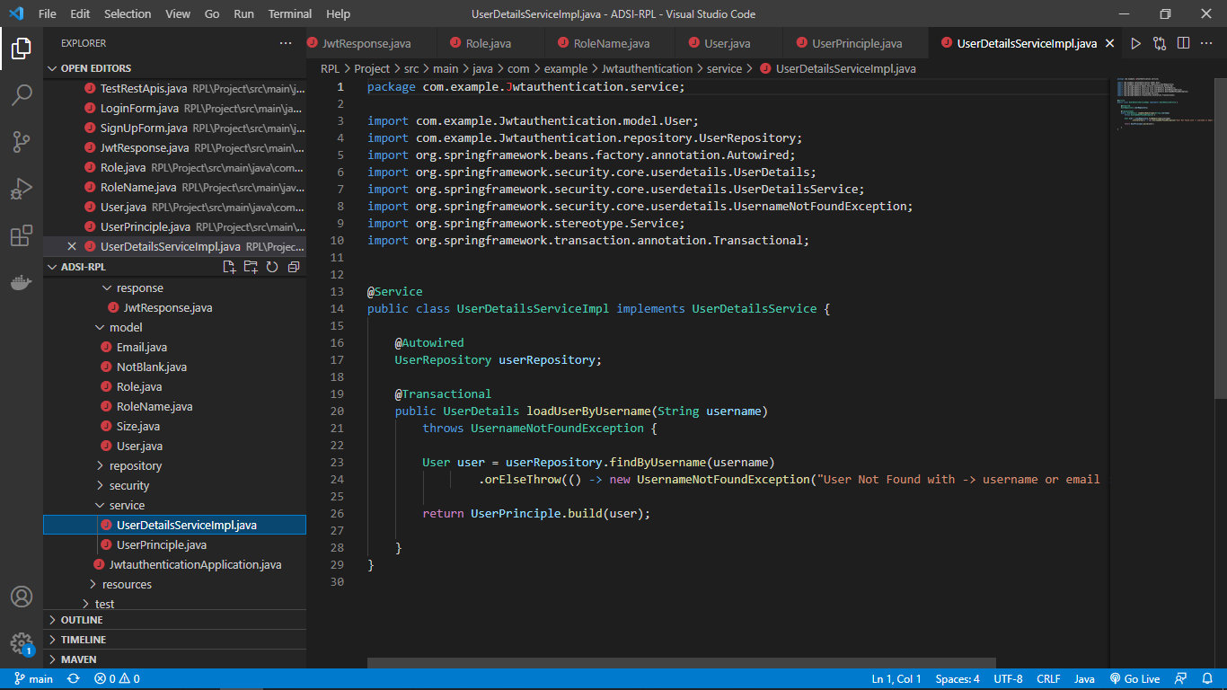

* UserPrinciple

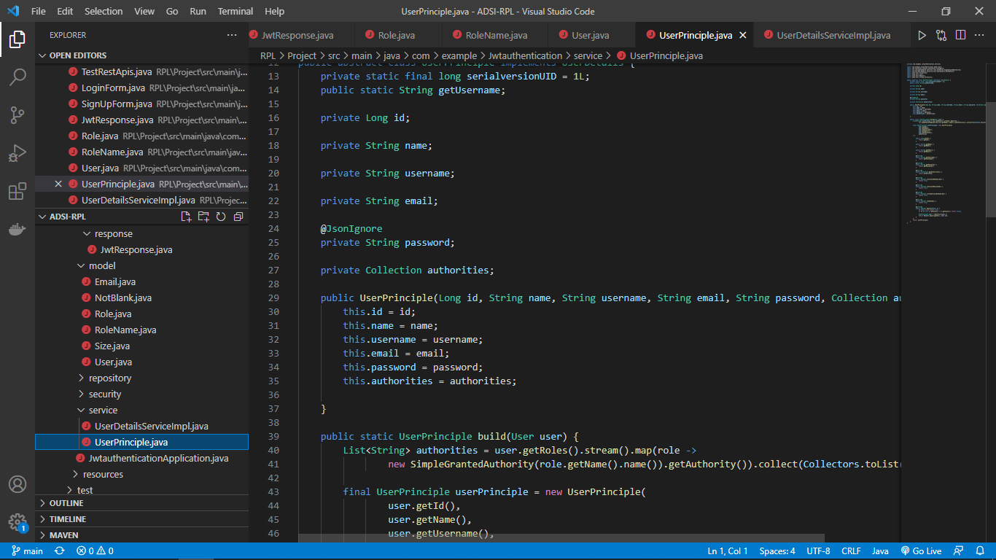

* AuthenticationApplication

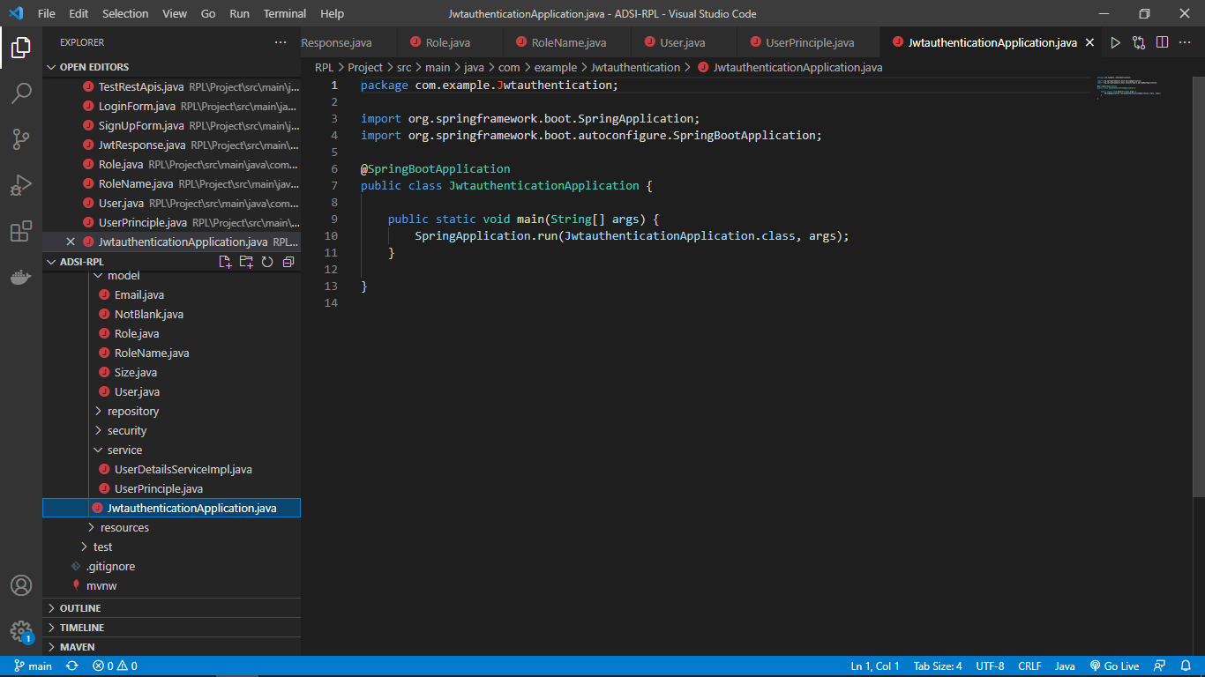

* Dependencies

